Soil and Soil erosion control strategies

Shih-Hao Jien

Geologic characteristics of Taiwan
Taiwan is located at the collision belt between Eurasian plate and the Philippines Sea Plate.
Taiwan is 394 kilometers long from north to south, and wide have 140 kilometers from east to west.
- Total area:36,000 km2
- Slopeland area (≥ 100 m):74%
- Maximum elevation: 3,952 m
- Average elevation of slopelands: 660 m
- Average slope gradient of slopelands:25 degree
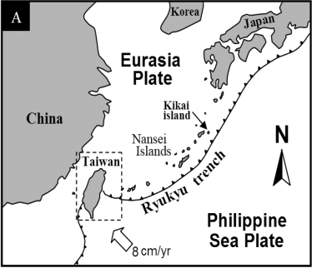

Rainfall amounts and Renewable internal freshwater resources capita
The average annual rainfall in Taiwan is about 2500mm/year, which is 2.6 times that of the world average, but the Renewable internal freshwater resources capita to each person are far below the world average. we got about 4000 meters cubic in Taiwan.
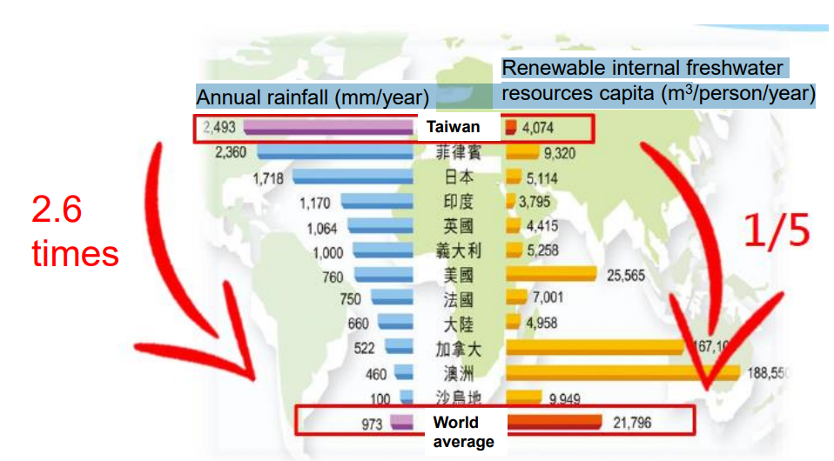

This is the distribution of rainfall across Taiwan in 2019.
we can find the very high annual rainfall amounts in Taiwan particularly in the north and Taiwan,It's more than 5900 millimeter/year and even in Yilan in eastern northern taiwan is about 6600 millimeter one year.
In southern Taiwan we also found the very high annual rainfall amount,it's about the 5500 millimeter per year.
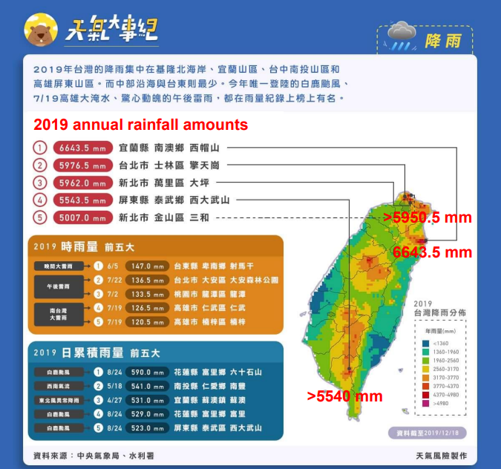

Sedimentation of major reservoirs in Taiwan
There are 18 important reservoirs in Taiwan, reservoirs can help us store water.
We can find much serious sedimentation situation was found in these six reservoirs, respectively Tseng Wen Reservoir, Shimen Reservoir, Nan Hua Reservoir,Wu Shan Tou Reservoir, Baihe Reservoir, Ming Te Reservoir. Amino in the Tseng-Wen reservoirs is serious sedimentation problem propeculily serious.
About the more than 30% storage capacity was occupied by the sedimentation,so that's why the reservoirs in Taiwan the life age is very short because the heavy rainfall and pool type graphics conditions.
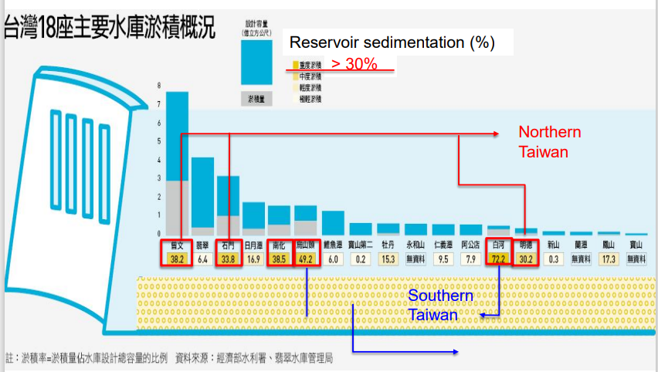
Multi-disasters in Taiwan
In Taiwan face to the multi-disasters in our countries include the 4 disasters.
- Soil erosion
- Landslides
- Debris flow
- Rock falls
But the government always focus on the landslides and Debris flow, few projects associated with the soil erosion or rock falls.
We just found some projects now hosted by the consultant companies.
They host a big project for soil erosion situation and the soil erosion monitoring in Tseng Wen Reservoir in Taiwan.
Disaster Prevention Technology Research Center, Sinotech Engineering Consultant, Inc. http://dptrc.sinotech.org.tw
The Acts regarding soil and water conservation
So to protect our country and to prevent the soil of erosion from the heavy rainfalls,we need to follow some act regarding soil and water conservation.
In Taiwan we got four major for act the soil and the water conservation.
- Slopeland Conservation and Utilization Act (from 1976)
- Enforcement Rules of Slopeland Conservation and Utilization Act
- Soil and Water Conservation Act (from 1994)
- Enforcement Rules of Soil and water Conservation Act
- Soil and Water Conservation Handbook (2019)

Soil erosion in Taiwan
- Most of soil erosion in Taiwan are resulted from unsuitable agricultural behaviors and overuse of slopelands.
- We have established basic databases for calculating soil erosion potential, such as soil types; soil erodibility factor (K factor) and soil erosivity (R factor) from1976.
- Soil survey in slopelands (1976-1987)
- Distribution of K factor (Wann and Huang,1989)
- Distribution of R factor (Huang et al.,1979; Lu et al., 2005)
- Distribution of soil erosion potential at some important watersheds in Taiwan (Chen et al., 2009; Lin et al., 2012)

History of Soil Survey in Taiwan
- Soil survey in Taiwan has been conducted by Japanese soil scientists for making the soil maps of pH and texture since 1920s.
- 20 survey projects were conducted as the important events in the past 50 years since 1950s.
- Some of significant contributions in providing very valuable information on human life, such as agricultural development, designing agricultural policy with ecological and environmental concern, and soil education.
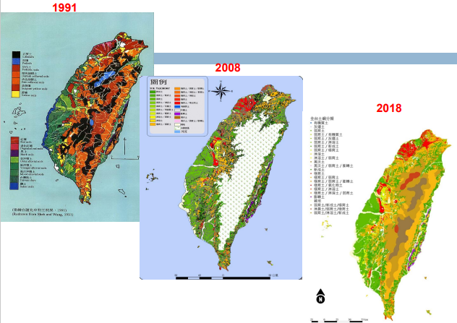

Important survey projects in the last 50 years in Taiwan (1946-2016)
- Reconnaissance soil survey of Taiwan (1946-1952) － Taiwan Agricultural Research Institute (TARI), Council of Agriculture
- Soil survey and soil fertility evaluation － Taiwan Fertilizer Company (TFC)
- Soil Survey of Taoyuan county － TFC
- Soil survey of Tobacco production of Taiwan － Department of Agricultural Chemistry, College of Taiwan Provincial Agriculture
- Soil survey of agricultural farms － Taiwan Sugar Company (TSC)
- Soil survey for land use of agriculture and forestry － TARI
- Soil survey of Tea production in Kuang-See township － Department of Agricultural Chemistry, National Taiwan University (DAC/NTU)
- Detail survey of Taiwan saline soils － DAC/NTU
- Soil survey and land use of Lu-Kang region of Changhwa county － TFC
- Soil survey of saline soil along seashore － TSC
- Detailed soil survey of Taiwan rural soils － National Chung Hsing University (NCHU) (1962-1976) and TARI (1974-1979)
- Soil survey of Southern region of Taipei Basin － TFC ◻
- Reconnaissance soil survey of Taiwan Forest soil － Forestry Bureau of Taiwan Province
- Detailed soil survey of Taiwan hill land (1980-1988) － Bureau of Agriculture and Livestock of Hill Land, Taiwan Province ◻
- Survey of contaminated soils (1984-2000) － NCHU, NTU, Agricultural Chemical and Toxic Materials Research Institute (TACTRI), and National Pingtung University of Science and Technology (NPUST) ◻
- Survey of soil productivity grade of upland in Taiwan (1986- 1990) － Department of Soil Science, NCHU (DSS/NCHU)
- Detailed soil survey of Taiwan forest soils, which the elevation ranged from 1000m to 4000m (1993-2002) － TFRI
- Detailed grid soil survey of Taiwan rural soils (2000-2010) － TARI
- Soil quality monitoring project after different soil management system (1997-2007) － TARI
- Project of soil resource information establishment in Taiwan (the 1st stage) (2008-2016) － TARI

8 most important soil survey projects of 19 items

Reconnaissance soil survey of Taiwan Province (1946-1952)
First one is the reconnaissance soil survey of Taiwan Province in the mid 20th century during the 1946 to 1952, and Soil survey was conducted by the TARI.
They also publish soil survey reports, soil mapping.
Soil survey was conducted by TARI
- 8 volumes of soil survey reports were published: Taichung, Penghu, Tainan, Kaohsiung, Pingtung, Taoyuan, Hsingchu, and Maoli
- Soil maps on the scale of 1:100,000
Soil mapping unit:
- Soil series, soil types and soil phase
All soil survey followed
- Soil Taxonomy (1938, USDA)

Detailed soil survey of Taiwan rural soils (1962-1976, 1974-1979)
National Chung Hsing University（NCHU）and TARI finished the eleven volumes of the soil survey reports soil survey books, and 180 soil maps is scale of the 1:25,000 scale during 1962 to 1979 is about 15 years.
Soil survey was conducted by DSS/NCHU during 1962-1976
- 7 volumes of soil survey reports were published
- 90 soil maps (1:25,000) were published
- 342 soil series were established
- Soil type as mapping unit (soil series + surface texture)
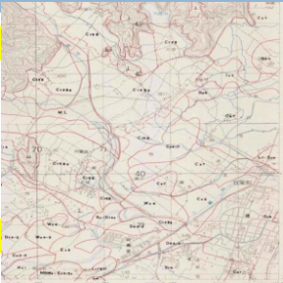
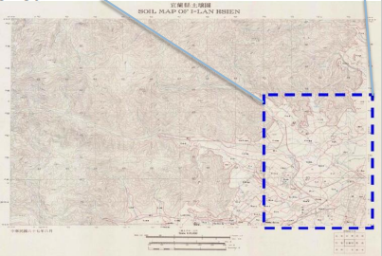
Soil survey was conducted by TARI during 1974-1979
- 4 volumes of soil survey reports were published
- 88 soil maps (1:25,000) were published
- 278 soil series were established
- Soil type as mapping unit

Detail soil survey of Taiwan hill lands (1980-1988)
Finished the 13 volumns of the soil survey books of the whole Taiwan Hill lands, And also about 215 soil maps on the scale of the 1 : 25,000 scale of soil map during 1980 to 1988.
Soil survey was conducted by Bureau of Agriculture and livestock of hill land
- 13 volumes of soil survey reports of whole Taiwan hill lands
- 215 soil maps on the scale of 1:25,000
- 432 soil series were established
- Soil phase as mapping unit (soil series + surface texture+ slopes)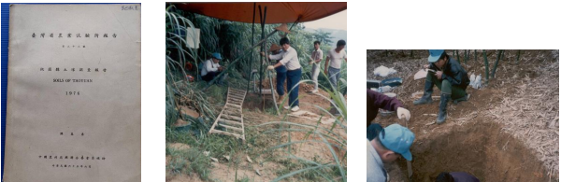

Soil survey of productivity grade of Taiwan upland (1986-1990)
National Chung Hsing University（NCHU） will soil survey of the productivity grade of the Taiwan uplands during the 1986 to 1990, and classified the four classes of the soil productivity in this survey.
Finally finished 168 soil maps of the soil productivity classes of the Taiwan upland in scale of 1 : 25000.
Soil survey was conducted by DSS/NCHU
- 4 classes of soil productivities were established, depend on
- the existence of texture changes of soil profile
- gray mottles formed at different soil depths
- 168 soil maps of soil productivity classes of Taiwan upland (1:25,000) were published

Soil survey of contaminated soils
(1984-2000)
NCHU, NTU, TACTRI and NPUST together make a very detailed soil survey for the contaminated soils.
Firstly, they use a very rough resolution to suffer the soil 4km to 4km, later increase the resolution 1km to 1km.
Finally they use another method they just focus on very small plots, 100 meters to 100 meters to check the real polluted for the soil, and then digitalized the surface works into the GIS systems.
Soil survey was conducted by NCHU, NTU, TACTRI and NPUST
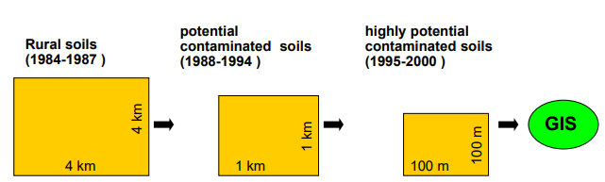
- ≧10,000 soil sampling locations, 150 potential polluted sites, and 5 seriously polluted sites have been included into this GIS system

Detailed soil survey of Taiwan forest soils in Mountains (1993-2002)
We contact survey the Taiwan Forest Soils in the end of the 20 century is about 1993 to 2002. In this project source was conducted by the Taiwan Forestry Forest Research Institute.They published 10 volumns of the soil survey reports and more than 200 soil maps 1 to 50000 in scale.Most forest soils could be classified include the Inceptiso,Entisols Altisols and Ultisols.then Inceptisols and Entisols occupied more than 75% in forest soil.
Soil survey was conducted by TFRI
- 10 volumes of soil survey reports were published
- ≧200 soil maps (1:50,000) were published
- 9 Soil Orders were classified
- < 50 soil series were established. ◻ Soil phase as mapping unit.
The major Soil Order distributed in the forest soils
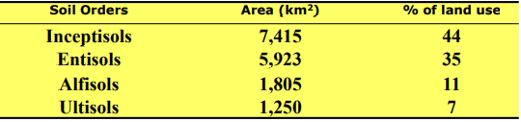
Detailed grid soil survey of Taiwan rural soils (2000-2010)
So during the 2000 to 2010, we have also very detailed grid soil survey of Taiwan rural soils hosted by TARI.
In this project, we sample the soil profile every 250 meters and based on the 1 to 5,000 area photo pictures.
We got many soil different depths, including the 0-15, 15-30cm, 30-60cm, 60-90cm, 90-120cm and over than 120cm in depth,total more than 130,000 soil profilese.
And the total 780,000 soil samples was analyzed and established in the database in whole Taiwan.
Final digitalize these database into the GIS systems, into the National Soil Information System of Taiwan.
Soil survey was conducted by TARI
- Sample interval
  - Every 250 meters based on 1:5,000 air photo pictures
- Sampling depth
  - 0-15cm, 15-30cm, 30-60cm, 60-90cm, 90-120cm, and 120-150cm depth
- ≧ 130,000 soil profiles (780,000 soil samples) database in whole Taiwan
  - Included into the GIS system of National Soil Information System of Taiwan
This picture you can find the fertility distribution in Tainan City based on the very detailed so survey,We can know the distribution of land fertility in more detail through the map displayed by GIS.
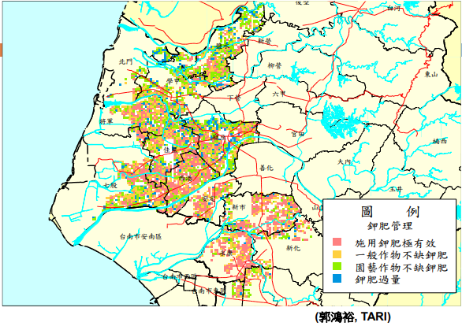
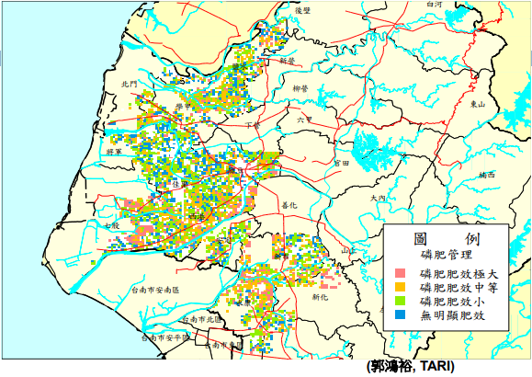
Soil Quality Monitoring project after different soil management system (1997-2007)
Council of the Agriculture wants to make some policy to will manage the different soil series.
So they want to know the soil quality before the management and after the management.
They want to use this to establish the soil quality indicators and know how to manage the agricultural soils in Taiwan.
- 150 rural soil sites were selected
  - Including different soils, crops, and climates conditions
  - Monitoring the changes of soil quality in each site
- Soil quality indicators
  - soil texture
  - pH
  - organic C
  - total N
  - exchangeable K, Na, Ca, Mg, and Mn (extracted by 0.1M sodium acetate at pH7)
  - soluble Fe, Mn, Cu, Zn, Cd, Pb, Cr, and Ni (extracted by 0.1M HCl)
  - available P, K, Ca, Mg, Na, B, Cu, Zn, Fe, and Mn (extracted by Mehlich #3 solution)

Land uses in slopelands and mountains (Taiwan)
In Taiwan, flat ground by 26%, highland by 74%, and slopelands by 65% for crop production, such as the tea planting and the pineapple planting and the latest planting at slopelands.
Due to the steep terrain and high mountains in Taiwan, there is very little agricultural land available on the flat land, so the people have turned to the slopeland to grow crops, cause over-reclamation, deforestation, denudation…etc behavior, make soil more fragile and reduce protect, finally cause disasters.
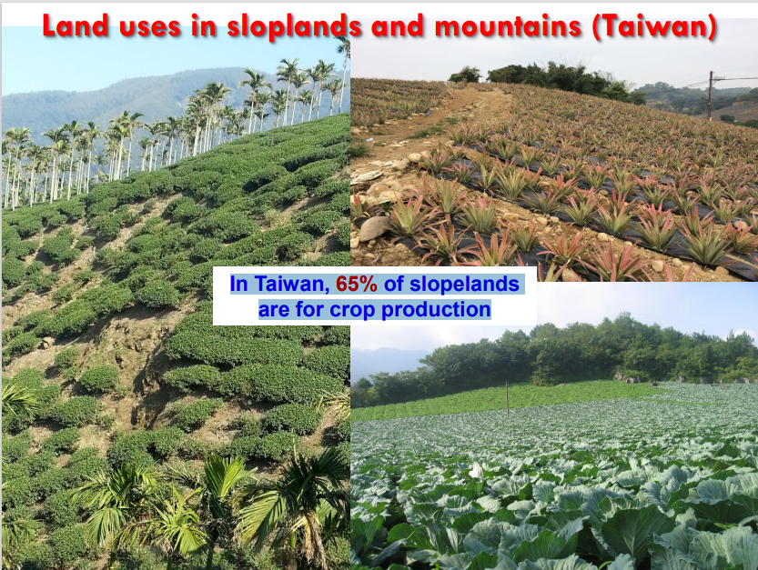
Cause serious soil erosion reason in Taiwan
- Over-using
In accordance with the regulations, as " suitable land for forestry" and "land for enhanced conservation", don't shall be engaged in the agriculture, forestry, fishing, and animal husbandry work.
- Unsuitable agricultural behaviors
Poor tillage techniques, resulting in soil damage, or excessive fertilization that disrupts the original balance of the soil
- Betel nut planting
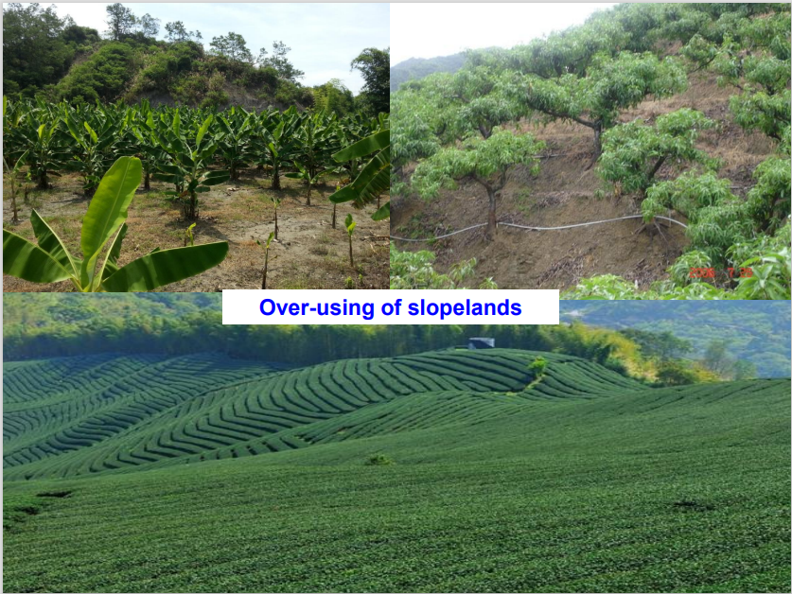
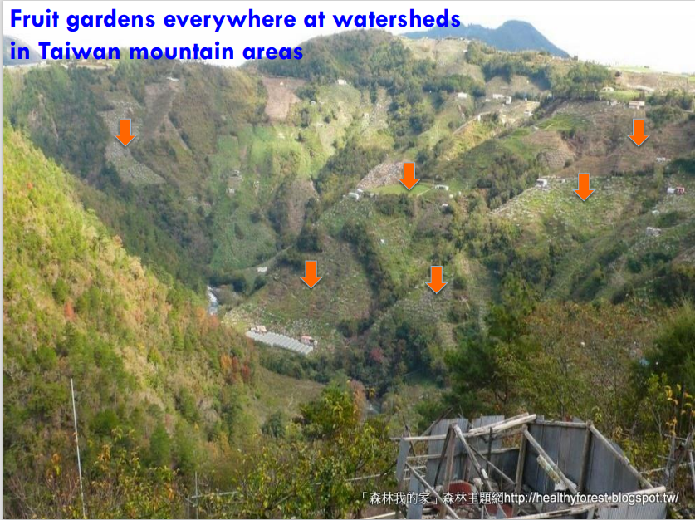
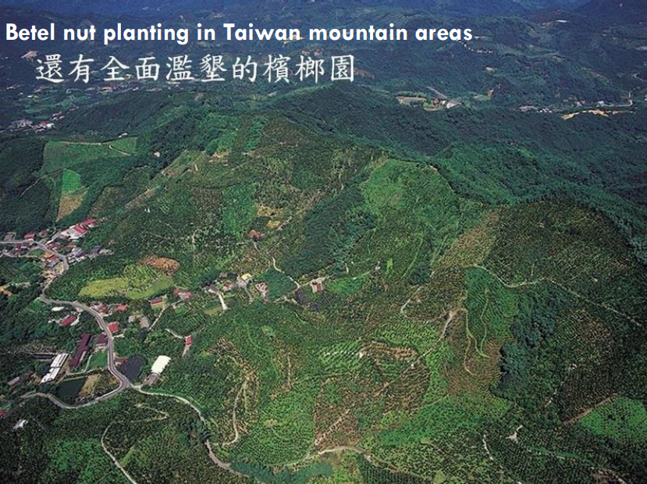

Soil erosion in Taiwan
Based on the Food and Agriculture Organization of the United Nations (FAO), the soil erosion rate is divided into the three categories.
- <5 tons/ha/yr of natural land with good surface cover or natural forest ecosystem
- 50 to 100 tons/ha/yr belong to moderate and Serious soil erosion rate
during the typhoon seasons
- more than 200 to 500 tons/ha/yr is belong to the extremely serious soil erosion rate.
caused by a strong storm owing to climate changes in last decade.
But in Taiwan still lack soil erosion map now, so issue is we need to develop a complete soil erosion map in Taiwan.

Soil loss evaluation in Taiwan
The Universal Soil Loss Equation (USLE), based on and developed from soil erosion data collected by the U.S. Department of Agriculture's Soil Conservation Service since the 1930s, is used to estimate annual soil loss on hillsides.
The Revised Universal Soil Loss Equation (RUSLE; or Modified Universal Soil Loss Equation, MUSLE) is modified from the basic theory of USLE, and continues to be used for similar purposes.
A = R*K*L*S*C*P
A factor (Soil loss volume)
R factor (Rainfalll erodibility factor)
K factor (Soil erodibility factor)
L factor (Slope length)
S factor (Slope gradient)
C factor (Cover and management factor)
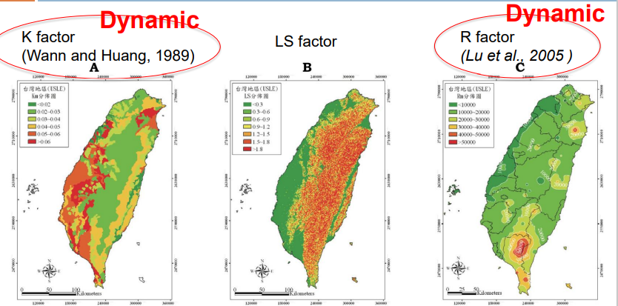
P factor (Soil and Water Conservation Factor)

Precipitation in Taiwan
Taiwan main rainfall in May to Sept.
In recent years, due to the influence of climate change in Taiwan, heavy rainfall has become more and more frequent. We can find that the number of rainy days has been decreasing every year, but the rainfall has not changed.
You can check the precipitation in Taiwan from the 1993 to 2012,
the blue square plot is mean to the annual precipitation and the red circle plot means the soil erosivity R factor.
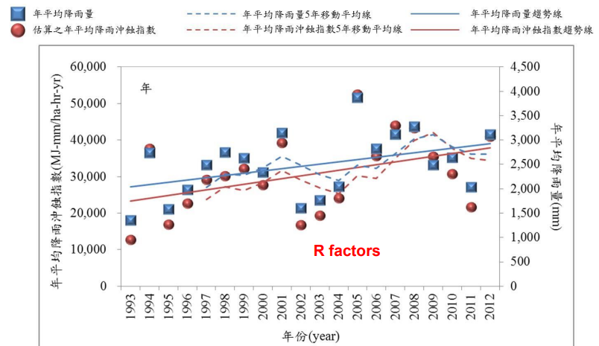

Changes of soil erodibility factor (K factor) at a terrace in southern Taiwan (for example in Laopi terrace)
Also, it's the same situation for the K factors.
We just take an example for the Laopi terrace in South Taiwan, this is the Laopi terrace in South Taiwan.
you can find the K factor increased 1.5 to 3.5 times after 20 years from the 0.01 to 0.02 and 0.015 to 0.075 in at the same subcatchment, particularly in this area.
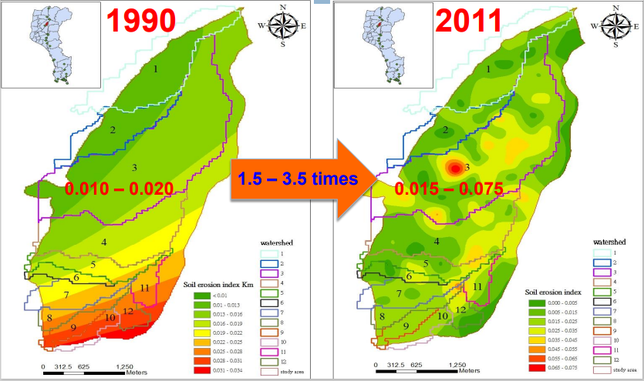

Why K factor change so obviously?
we found maybe land use change is the main reason to cause the K factor change.
You can find this particularly in this area from the forest and change to some dry farmlands from the 1990 to 2011.
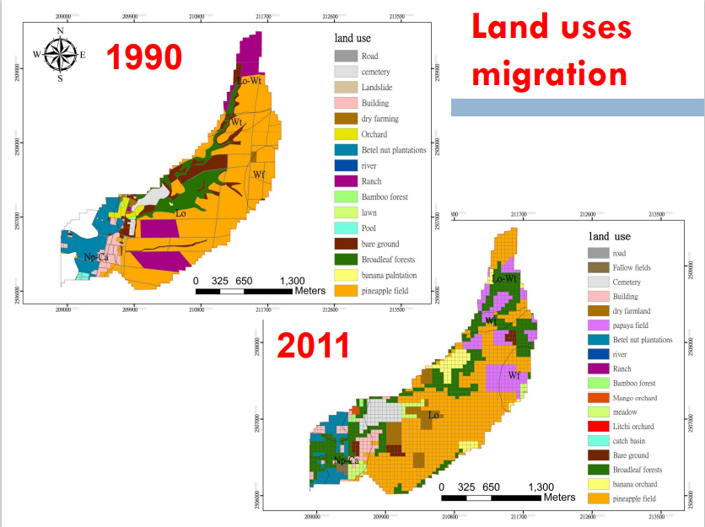
Which land use do result in most serious soil erosion in agricultural slopelands?
This is a Laopi landuses image.
We can see the bare lands K factor most tall is 0.022, and broadleaf most low is 0.016.
If the land use changes from the forest to bare lands, or to from forest to banana planting, I think the K factors will changes increased obviously from the 0.016 to 0.021 or 0.024.
So landuse
Therefore, the land use has a great influence on the K factor.
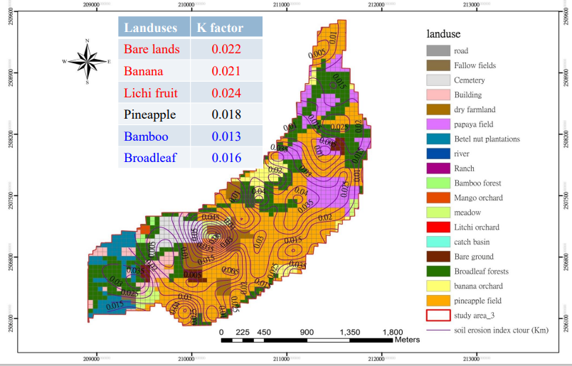

Soil loss evaluation in Shihmen watershed
(northern Taiwan)
A image is K factor, B image is R factor, C image is LS factor, D image is C factor, final use ULSE equation merge Soil Erosion Potential image.
We see the image, we can know that the soil erosion is more serious in the north and east(Red) of Shihmen Reservoir, and the lowest erosion situation is in the south(green).
I think it is because the north and east are upstream, and the river water is more turbulent, resulting in higher erosion.
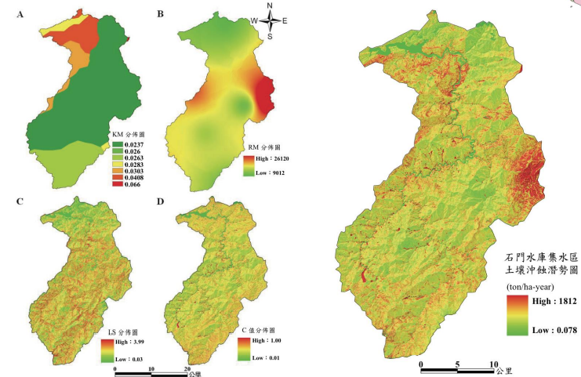

Common techniques for preventing top soil erosion in Taiwan
Introduce some common techniques for preventing soil erosions in Taiwan to you.
We have three kinds of the methods including the engineering methods, agronomic and vegetation methods.
For the engineering methods is maybe most of the methods is used in the river, and for the agronomic methods, I think this methods is always used in the slopeland.
You also combine these three methods on one slopeland and you also can use the one methods slopelands, only depend on the environmental state for the slopelands.

Agronomic methods
- Contour planting
- Bench terrace
- Mulching
- Drainage ditch

Engineer methods (usually used for steep slopes : > 40 degree)
- Geotextile mets
- Piling and wattling
- Retention pond
- Deposit pond
- Drainage gauge
- Retaining wall
- Check dam
- Slit dam
- Spur dike
10. Earth-filing dam
Vegetation methods
- Sowing
- Direct sowing
- Spray planting
- Vegetation bags
- Soil bags
- Tree planting
- Grass planting
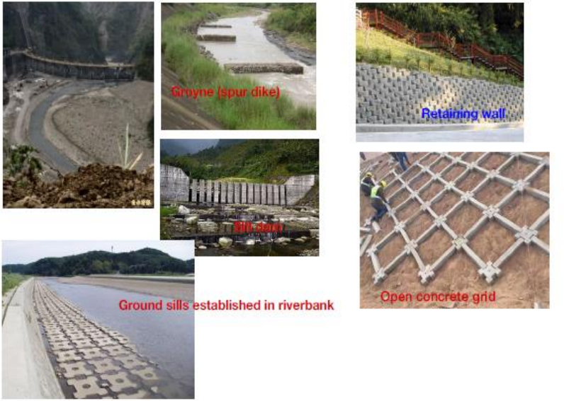
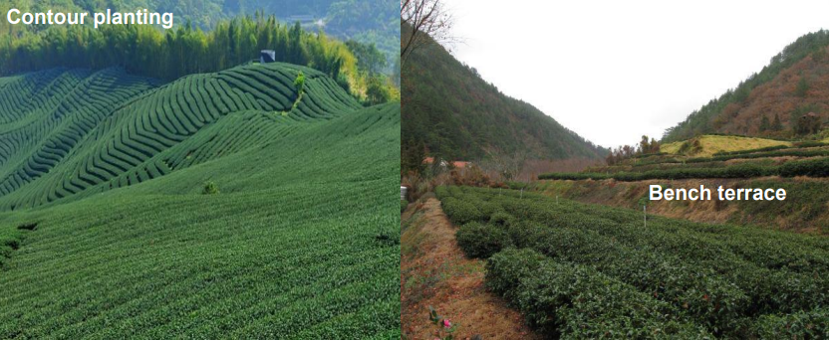
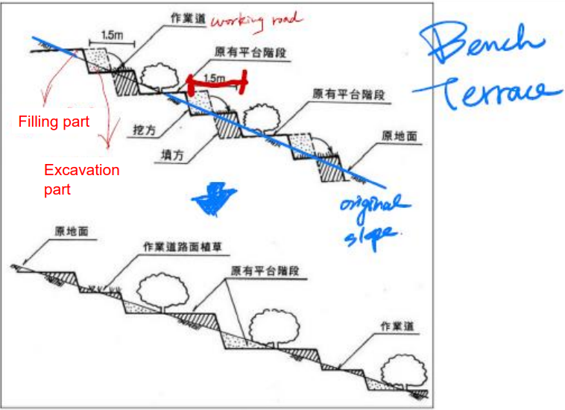
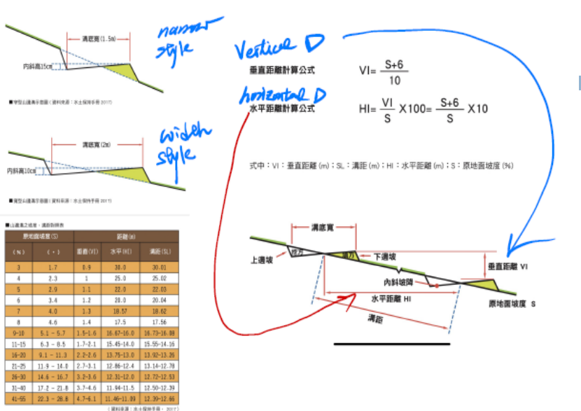

Case study in reducing soil erosion in Lichi garden by different agronomic methods (Chiang, 2005)
This is test area located at the National Pingtung University of Science Technology, The slope gradient is 31 degree and the slope length is 22.1 meter and the width is 4 meters.
This reference is published by Chiang 2005.
A is the treatment is cover with grass and the lichi fruit
B treatments is cover with grass and we have drainage ditch
C treatment is without cover and mulching just lichi planting
D treatment is mulching with grass residuals.
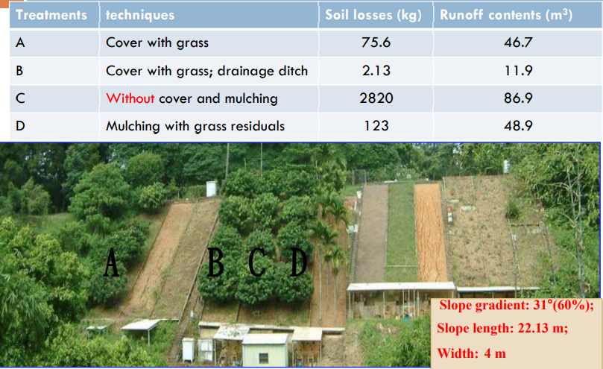
Engineering methods
One is covered by rolled erosion control products RECPs and the land Spray seedling, first you covered these products and then spray seeding planting later.
Another is the piling and wattling, you can find the pile, maybe the distance for each pile maybe 30 to 50cm, and one third you need to out of the soil service just like this.
But the prevention affects activities is not so good, so now we don't use this methods anymore.
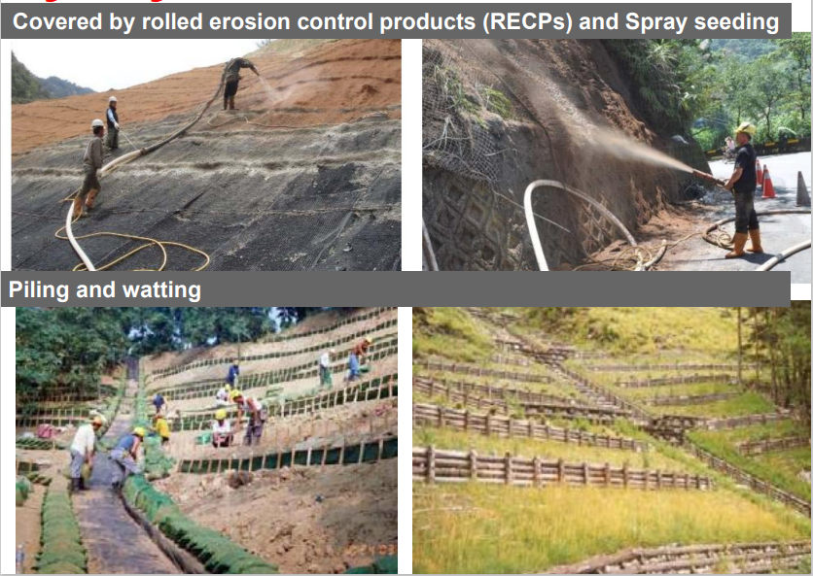
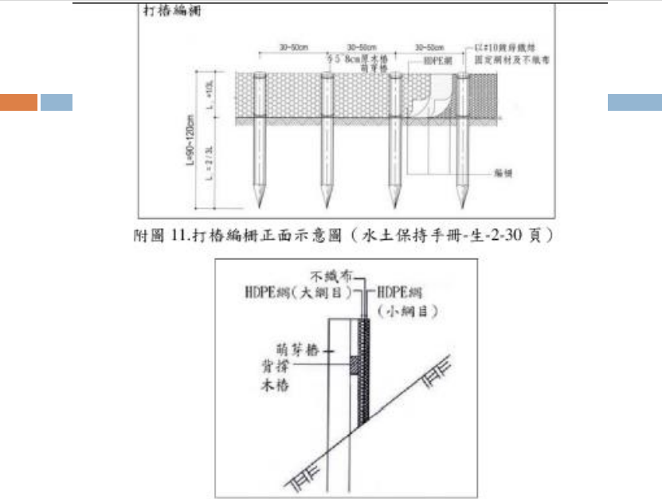

Case study in reducing soil erosion at watersheds in Shihmen reservoir by different engineering methods
(Linet al., 2013) 2008.09 – 2010.12
This reference is published by Linet 2013.
They used three engineering methods, mulch, covered by the road erosion control products and piling and watting in the Tseng-Wen and shihmen watershed.
During the 2008 to 2010 year and monitoring the soil erosion mounts, they found the best one, the best answer is covered by rolled erosion control products, it can reduce the 55% of the soil losses, and the second one is the mulch, It could reduce the 41% of the soil losses, the bad one is the panel in the white, it just reduced about 18% of soil losses.
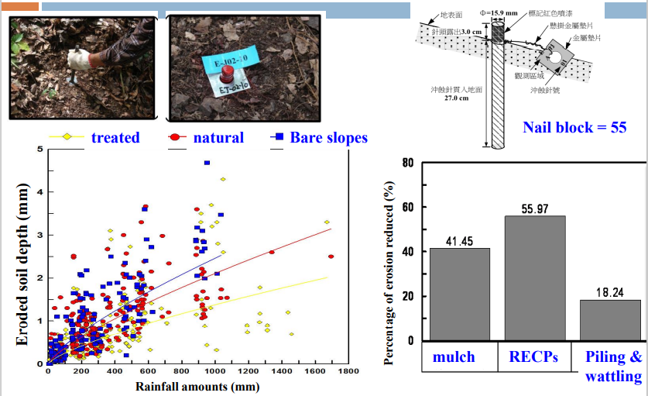
Strategies of preventing top soil erosion
- Establishment of regulations in using limitation of slopelands.
- Development and selection of suitable agronomic and engineering techniques for soil loss reducing, particularly in high soil erosion areas.

Slope gradient
- S1= Slope gradient < 5%
- S2=5% < Slope gradient < 15%
- S3= 16% <Slope gradient < 30%
- S4= 31% <Slope gradient < 40%
- S5= 41% <Slope gradient < 55%
- S6= Slope gradient > 55%
Slope depth
- D1= Slope depth > 90cm
- D2= 51cm < Slope depth < 90cm
- D3= 20cm < Slope depth < 50cm
- D4= Slope depth < 20cm
We divide into the 1234 degrees it belongs to the Agricultural uses slopelands, and 5 degrees belong to forest, and 6 degrees belong to conserved.
If you match the criteria for these four degrees, but have a very steep slope gradient and very shallow so depth, you just maybe can use only for forest planting.
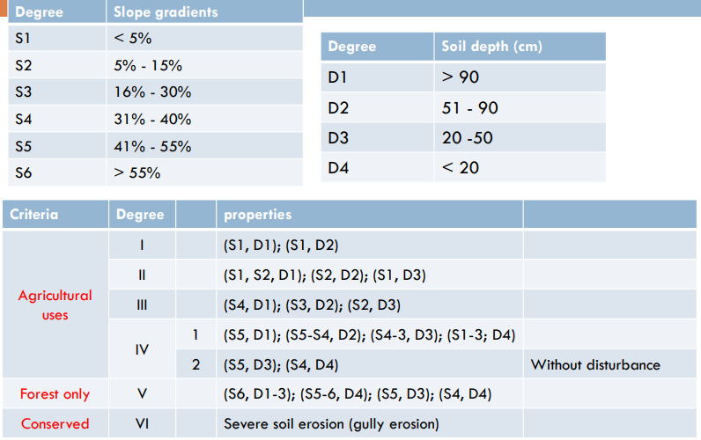

Strategies to prevent soil loss in Taiwan
we could conclude that the best management practices (BMPs) to reduce top soil loss in last 3 decades in Taiwan

For the agronomic methods maybe contour planting and bench terrace is based on one practice.
For slopeland for the agricultural purpose and maybe Grass Cover and combined with drainage ditch is also very good practice for prevent soil erosion on slope lands.
For the engineering methods maybe covered by rolled erosion control products is a good techniques.
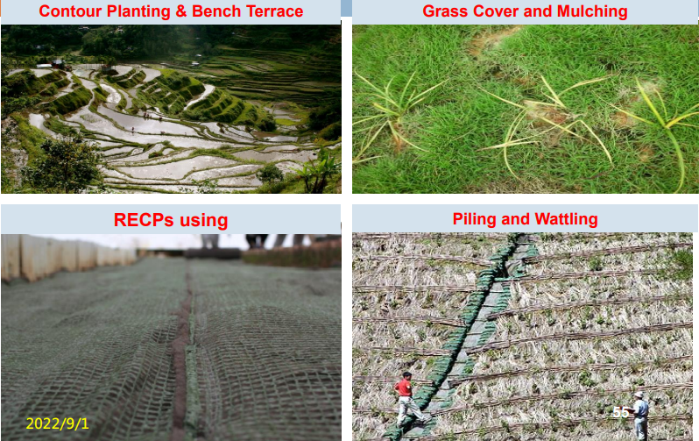

Conclusions
So our conclusions where establishment of basic database is necessary before soil erosion potential evaluation
You use the R factors and K factors and C factors to redevelop the soil erosion map in Taiwan, then you can check the most serious area and to select the suitable techniques to prevent soil erosion, and also you need to focus on areas with high erosion potential and select suitable conserved techniques, and best management practices to minimize impaction on soils and environment

Based on the slope gradient you can choose different prevention techniques in Taiwan slopelands.

