Basic Hydrology

Jie-Lun Chiang

Hydrology cycle
Let’s review the hydrology cycle. This cycle starts with evaporation (from ocean and land). During known processes in the air, it will change to precipitation and come to land and ocean again. Some part of precipitation will infilter in the soil where can recharge groundwater and extra amount of water (in saturation layer of soil) change into groundwater flow and finally discharge to the ocean. Some part will store by lake, river, dam, that we mention it as a freshwater.
There is also excess rainfall. That amount of Rainfall is neither retained on the land surface nor infiltrated into the soil. Graph of excess rainfall versus time is called excess rainfall hyetograph. The volume of rainfall available for direct surface runoff.
Excess rainfall = observed rainfall – abstractions (interception, depression storage, and infiltration)
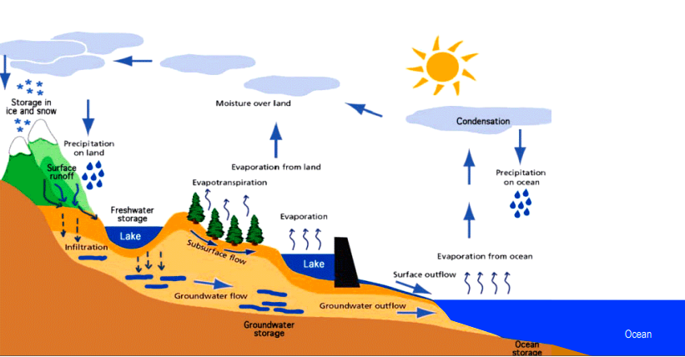
When we talk about the movement of water in a watershed, we need to know the meaning of runoff and streamflow.
Runoff is that portion of precipitation or irrigation on an area that does not infiltrate or evaporate
Streamflow, or discharge, is the volume of water that moves over a designated point over a fixed period of time. The flow of a stream is directly related to the amount of water moving off the watershed into the stream channel.
Direct runoff = observed streamflow - baseflow
Baseflow is a portion of streamflow that is not directly generated from the excess rainfall during a storm event. In other words, this is the flow that would exist in the stream without the contribution of direct runoff from the rainfall.
The figure below is a Direct Runoff Hydrograph. Q is discharge.
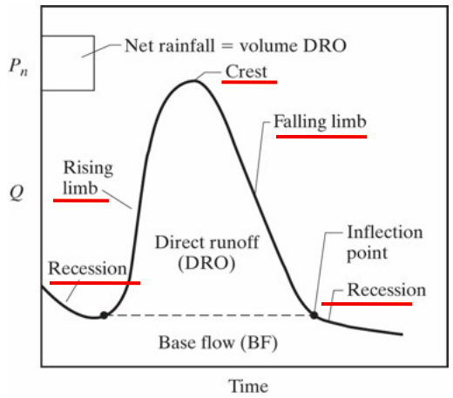

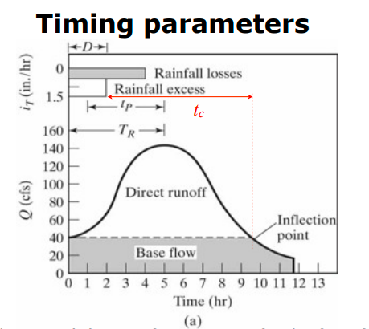
- Duration of rainfall excess (D): time from start to finish of rainfall excess
- Lag time (L or t p): time from the center of mass of rainfall excess to the peak of the hydrograph - Time of rise (TR): time from the start of rainfall excess to the peak of the hydrograph
- Time of concentration (tc): time for a wave (of water) propagate from the most distant pt in the watershed to the outlet. One estimate is time from the end of net rainfall to the inflection pt.
- Time base (Tb): total duration of the DRO hydrograph

Areal Precipitation
Generally, we work on watersheds and each watershed includes different rainfall stations that spread along the watershed. The important point is each station can show the rainfall at the exact point of the station's location. Since we need to work on one area we consider as a watershed, it is necessary to change the precipitation point to precipitation area. That means by using methods we try to calculate precipitation for a particular area. There are different methods like Thiessen Polygon, Isohyetal Analysis, Arithmetic Mean, Distance Weighting/Gridded, and MAPX.
Mostly use Thiessen Polygon that is a graphical technique that calculates station weights based on the relative areas of each measurement station in the Thiessen polygon network. The individual weights are multiplied by the station observation and the values are summed to obtain the areal average precipitation.
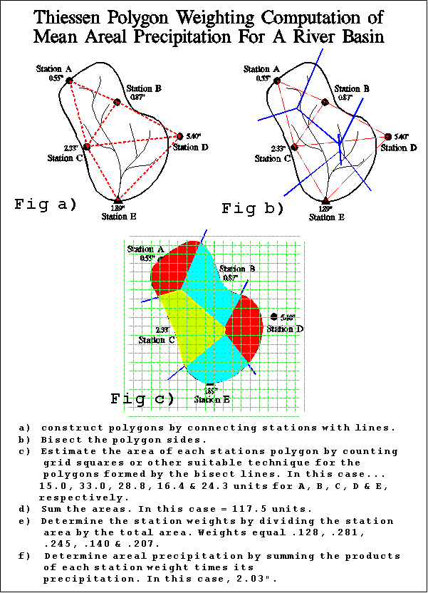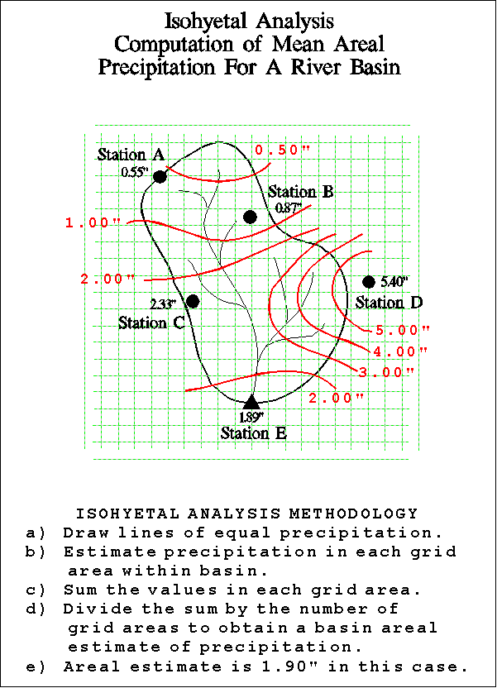

Also, Isohyetal Analysis is another graphical technique which involves drawing estimated lines of equal rainfall over an area based on point measurements. The magnitude and extent of the resultant rainfall areas of coverage are then considered versus the area in question in order to estimate the areal precipitation value.
We know after rainfall some part of it evaporate, some part recharge groundwater and another part become runoff and discharge of watershed from out let. To estimate direct runoff hydrograph (DRH), we need unit hydrograph. In order to use unit hydrograph as a tool for predicting direct runoff hydrograph, we first need to derive a unit hydrograph for a given watershed.

Unit hydrograph
Unit hydrograph is a direct runoff hydrograph resulting from one unit (one inch or one cm) of constant intensity uniform rainfall occurring over the entire watershed.
For example, if one mm of excess rainfall produces a direct runoff peak of 100 mm then two mm of excess rainfall with produce a direct runoff of 2 x 100 = 200 mm.
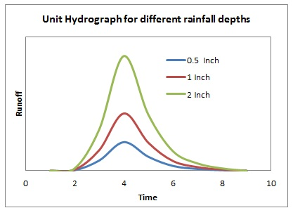
Example
We have all data of from a rainfall gauge. Table shows excess rainfall and the consequent direct runoff values are available at 15-minute intervals.
The first step is to compute the total volume of direct runoff. To do this, add all direct runoff values, and multiply the sum of all the direct runoff flows by the time interval (in seconds) convert cubic feet per second to cubic feet of volume. After getting the total runoff volume, find the equivalent runoff depth by dividing the runoff volume by the basin area. Note that, the depth thus calculated is equal to the total excess rainfall depth.
data of from a rainfall gauge
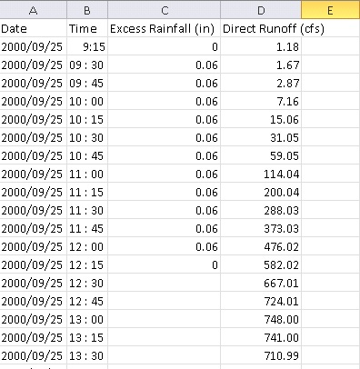
Calculate Total DRH
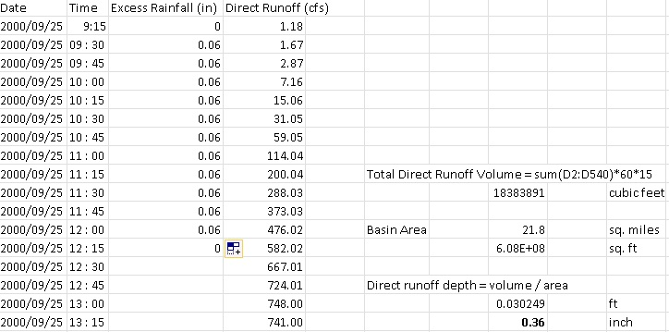

By definition, Unit Hydrograph is a direct runoff hydrograph resulting from the unit depth of effective rainfall. So, the ordinates of required UH can simply be obtained by dividing the ordinates of Direct Runoff Hydrograph by the equivalent depth of total direct runoff as shown below.
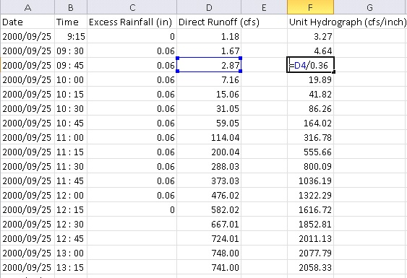
Once you get the unit hydrograph, the next step is to identify its duration. In the Unit Hydrograph definition, the duration of a unit hydrograph is the time period over which the excess rainfall occurred. In the dataset above, excess rainfall occurs from 9:30 AM to 12:00 PM, and hence the duration of the derived unit hydrograph is 2.5 hours.
The conventional graphical representation of the Direct Runoff Hydrograph and the derived Unit Hydrograph ordinates can be obtained by plotting the direct runoff and UH ordinates against time axis in Excel. The scatter plot hence obtained depicts the direct runoff hydrograph and the derived unit hydrograph of 2.5 hr duration for the given basin.
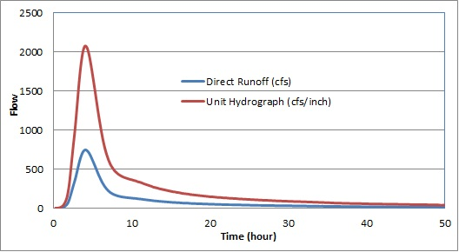
Now this unit hydrograph can be used to derive runoff hydrographs from rainfall data.
Application of Unit Hydrograph to Derive Runoff Hydrograph
For example, if a rainfall of P1 inches occurs during a time interval of Δt, the total runoff hydrograph is P1 multiplied by the total unit hydrograph, which is the blue curve (PUH_1) in the figure below. If the rainfall stops after Δt, this is the direct runoff hydrograph. If the rainfall continues with P2 inches (P2 may or may not be equal to P1) during the next time interval, the total unit hydrograph is again multiplied by the unit hydrograph to get the direct runoff hydrograph from P2 (PUH_2, shown in red). Because P2 occurs after Δt, the red curve is delayed or lagged by Δt in the figure. If the rainfall stops after P2, the total runoff hydrograph (green) is the addition of blue curve and red curve in the figure below. If the rainfall continues with P3, the same procedure is repeated with the P3 component of direct runoff hydrograph delayed by 2*Δt, and added to the red and blue curve to get the total runoff hydrograph.
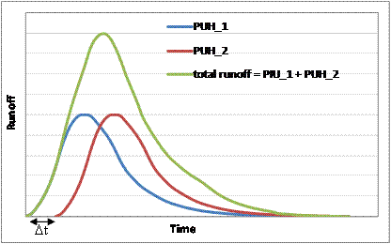
Once the concept of how a unit hydrograph is used is clear from the graphical example, it is now easy to apply this concept in Excel. The data provided with this step has the following format (shown in figure below) for a direct runoff and unit hydrograph:
Example:
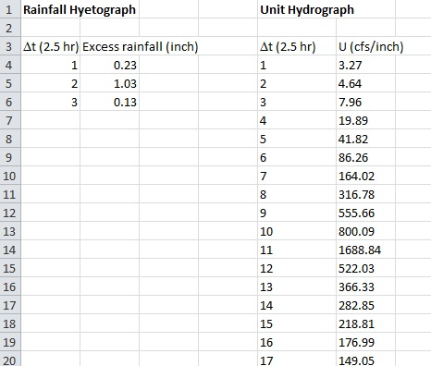
A direct runoff hydrograph can be obtained by using the discrete form of convolution integral as shown below.
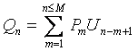
Where Q is the runoff ordinate, P is the rainfall pulse and U is the unit hydrograph ordinate.
Application of this equation in Excel involves the following steps:
- Multiply the entire unit hydrograph (UH) by the first rainfall pulse (P1). Lets call this the PUH_1 hydrograph.
- Obtain the PUH_2 hydrograph by multiplying the unit hydrograph by the second rainfall pulse. Delay or lag Q2 by Δt.
- Repeat step 2 to obtain PUH_3, PUH_4,..., PUH_M, where M is the total number of rainfall pulses. In this dataset, M = 3 so we can stop after 3. Remember PUH_3 is delayed by additional Δt compared to PUH_2.
- Sum all the PUH columns (PUH_1 + PUH_2 + ....+ PUH_M) to get the direct runoff hydrograph. The total number of direct runoff ordinates (N) must be equal to U + M – 1. Where U is the total number of unit hydrograph ordinates.
Computation of PUH_1, PUH_2,..., PUH_M and the total runoff hydrograph is shown below for the given data. The yellow cells represent the unit hydrograph, the green cells represent the precipitation, purple cells represent PUH, and the blue cells represent the total runoff hydrograph. The runoff hydrograph is obtained by summing all the PUH columns. Note how the delay in each PUH is accomplished by just inserting one additional empty cell for each PUH. Because the last PUH (PUH_3) is lagged or delayed by 2 cells or 6Δt, the total runoff hydrograph will have 2 additional ordinates compared to the unit hydrograph ordinates.
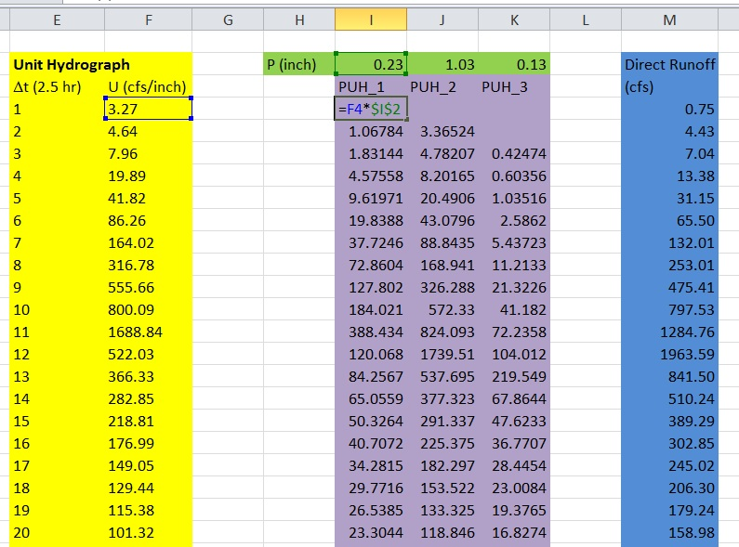
OK, now you know how to apply unit hydrograph to derive a direct runoff hydrograph from rainfall data

Example
UNIT HYDROGRAPHS

1. Obtain a Unit Hydrograph for a basin of 282.6 km² of area using the rainfall and streamflow data tabulated below.
Time  (h) | Observed Hydrograph (m³/s)
0 | 160
1 | 150
2 | 350
3 | 800
4 | 1200
5 | 900
6 | 750
7 | 550
8 | 350
9 | 225
10 | 150
11 | 140

Time  (h) | Gross Precipitation (GRH)  (cm/h)
0 - 1 | 0.25
1 - 2 | 2.75
2 - 3 | 2.75
3 - 4 | 0.25

In this process: use the horizontal straight-line method to separate baseflow.

Empirical Unit Hydrograph Derivation
1. Separate the baseflow from the observed streamflow hydrograph in order to obtain the Direct Runoff Hydrograph (DRH).

For this example, use the horizontal line method to separate the baseflow. From observation of the hydrograph data, the streamflow at the start of the rising limb of the hydrograph is 150 m³/s. Thus, use 150 m³/s as the baseflow.

2. Compute the volume of Direct Runoff. This volume must be equal to the volume of the Effective Rainfall Hyetograph (ERH).

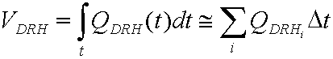
Thus, for this example:
V_{DRH} = (200+650+1050+750+600+400+200+75) m³/s (3600) s = 14'130,000 m³

3. Express V_{DRH} in equivalent units of depth:

V_{DRH} in equivalent units of depth = V_{DRH}/A_{basin} = 14'130,000 m³/(282600000 m²) = 0.05 m = 5 cm.

4. Obtain a Unit Hydrograph by normalizing the DRH. Normalizing implies dividing the ordinates of the DRH by the V_{DRH} in equivalent units of depth.

Time (h) | Observed Hydrograph (m³/s) | Direct Runoff Hydrograph (DRH) (m³/s) | Unit Hydrograph (m³/s/cm)
0 | 160 | 10 | --
1 | 150 | 0 | 0
2 | 350 | 200 | 40
3 | 800 | 650 | 130
4 | 1200 | 1050 | 210
5 | 900 | 750 | 150
6 | 750 | 600 | 120
7 | 550 | 400 | 80
8 | 350 | 200 | 40
9 | 225 | 75 | 15
10 | 150 | 0 | 0
11 | 140 | 0 | 0

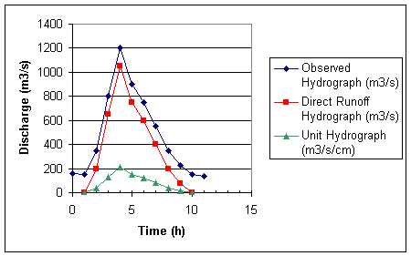

5. Determine the duration D of the ERH associated with the UH obtained in 4. In order to do this:
a) Determine the volume of losses, V_{Losses} which is equal to the difference between the volume of gross rainfall, V_{GRH}, and the volume of the direct runoff hydrograph, V_{DRH} .
V_{Losses} = V_{GRH} - V_{DRH} = (0.25 + 2.75 + 2.75 +0.25) cm/h 1 h - 5 cm = 1 cm

b) Compute the f-index equal to the ratio of the volume of losses to the rainfall duration, t_{r}. Thus,

f-index = V_{Losses}/t_{r} = 1 cm / 4 h = 0.25 cm/h

c) Determine the ERH by subtracting the infiltration (e.g., f-index) from the GRH:

Time  (h) | Effective Precipitation (ERH)  (cm/h)
0 - 1 | 0.0
1 - 2 | 2.5
2 - 3 | 2.5
3 - 4 | 0.0

As observed in the table, the duration of the effective rainfall hyetograph is 2 hours. Thus, D = 2 hours, and the Unit Hydrograph obtained above is a 2-hour Unit Hydrograph. Therefore, it can be used to predict runoff from precipitation events whose effective rainfall hyetographs can be represented as a sequence of uniform intensity (rectangular) pulses each of duration D. This is accomplished by using the principles of superposition and proportionality, encoded in the discrete convolution equation:

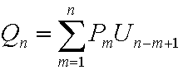
where Q_{n} is the n^{th} ordinate of the DRH, P_{m} is the volume of the m^{th} rainfall pulse expressed in units of equivalent depth (e.g., cm or in), and U_{n-m+1} is the (n-m+1)^{th} ordinate of the UH, expressed in units of m³/s/cm.

2. For the basin of Problem 1, predict the total streamflow hydrograph that would be observed as a result of a storm whose effective rainfall is tabulated below. Use the same value of baseflow as for Problem 1.

Time  (h) | Effective Precipitation (ERH)  (cm/h)
0 - 1 | 1.0
1 - 2 | 1.0
2 - 3 | 1.5
3 - 4 | 1.5
4 - 5 | 0.75
5 - 6 | 0.75
6 - 7 | 0.25
7 - 8 | 0.25

As observed in the table, the ERH can be decomposed into a sequence of rectangular pulses, each of 2 hours duration. Thus, we can use the 2-hour UH obtained in Problem 1. To do so:

1. Determine the volume of each ERH pulse, P_{m}, expressed in units of equivalent depth:

Time  (h) | P_{m}  (cm)
0 - 2 | 2.0
2 - 4 | 3.0
4 - 6 | 1.5
6 - 8 | 0.5

2. Use superposition and proportionality principles:

 | 1 | 2 | 3 | 4 | 5 | 6 | 7
Time(h) | UH (m³/s/cm) | P₁*UH (m³/s) | P₂*UH (m³/s) | P₃*UH (m³/s) | P₄*UH (m³/s) | DRH (m³/s) | Total (m³/s)
1 | 0.00 | 0.00 |  |  |  | 0.00 | 150.00
2 | 40.00 | 80.00 |  |  |  | 80.00 | 230.00
3 | 130.00 | 260.00 | 0.00 |  |  | 260.00 | 410.00
4 | 210.00 | 420.00 | 120.00 |  |  | 540.00 | 690.00
5 | 150.00 | 300.00 | 390.00 | 0.00 |  | 690.00 | 840.00
6 | 120.00 | 240.00 | 630.00 | 60.00 |  | 930.00 | 1080.00
7 | 80.00 | 160.00 | 450.00 | 195.00 | 0.00 | 805.00 | 955.00
8 | 40.00 | 80.00 | 360.00 | 315.00 | 20.00 | 775.00 | 925.00
9 | 15.00 | 30.00 | 240.00 | 225.00 | 65.00 | 560.00 | 710.00
10 | 0.00 | 0.00 | 120.00 | 180.00 | 105.00 | 405.00 | 555.00
11 |  |  | 45.00 | 120.00 | 75.00 | 240.00 | 390.00
12 |  |  | 0.00 | 60.00 | 60.00 | 120.00 | 270.00
13 |  |  |  | 22.50 | 40.00 | 62.50 | 212.50
14 |  |  |  | 0.00 | 20.00 | 20.00 | 170.00
15 |  |  |  |  | 7.50 | 7.50 | 157.50
16 |  |  |  |  | 0.00 | 0.00 | 150.00

a) Columns 2 - 5: Apply the proportionality principle to scale the UH by the actual volume of the corresponding rectangular pulse, P_{m}. Observe that the resulting hydrographs are lagged so that their origins coincide with the time of occurrence of the corresponding rainfall pulse.

b) Column 6: Apply the superposition principle to obtain the DRH by summing up Columns 2 - 5.

c) Column 7: Add back the baseflow in order to obtain the Total Streamflow Hydrograph.
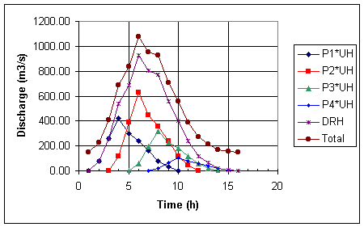

3. Use the 1-h Unit Hydrograph tabulated below to predict the total streamflow hydrograph that would be observed as a result of a storm whose effective rainfall is also tabulated below. Use the same value of baseflow as for Problem 1. Obtain the solution using the S-Hydrograph method.
Time  (h) | 1-H Unit Hydrograph (m³/s/cm)
1 | 0.00
2 | 40.00
3 | 130.00
4 | 210.00
5 | 150.00
6 | 120.00
7 | 80.00
8 | 40.00
9 | 15.00
10 | 0.00

Time  (h) | Effective Precipitation (ERH)  (cm/h)
0 - 3 | 1.0
3 - 6 | 2.0
6 - 9 | 1.5

The ERH is composed of 3 rectangular pulses of 3-hour duration each. Thus, we need a 3-h Unit Hydrograph. Since the only available hydrograph is a 1-h Unit Hydrograph, we need to develop a new 3-h UH using the S-Hydrograph method, as illustrated below. Observe that the S-hydrograph is obtained in 2 different ways: a) in tabular form as the superposition of an infinite sequence of 1-h UH's each lagged by 1-h; and b) as the cumulative volume of UH per unit time.

Time (h) | UH (m³/s/cm) | UH(t-1) (m³/s/cm) | UH(t-2) (m³/s/cm) | UH(t-3) | UH(t-4) (m³/s/cm) | UH(t-5) (m³/s/cm) | UH(t-6) (m³/s/cm) | UH(t-7) (m³/s/cm) | UH(t-8) (m³/s/cm) | UH(t-9) (m³/s/cm) | S-Hydr. (m³/s/cm)
1 | 0 |  |  |  |  |  |  |  |  |  | 0
2 | 40 | 0 |  |  |  |  |  |  |  |  | 40
3 | 130 | 40 | 0 |  |  |  |  |  |  |  | 170
4 | 210 | 130 | 40 | 0 |  |  |  |  |  |  | 380
5 | 150 | 210 | 130 | 40 | 0 |  |  |  |  |  | 530
6 | 120 | 150 | 210 | 130 | 40 | 0 |  |  |  |  | 650
7 | 80 | 120 | 150 | 210 | 130 | 40 | 0 |  |  |  | 730
8 | 40 | 80 | 120 | 150 | 210 | 130 | 40 | 0 |  |  | 770
9 | 15 | 40 | 80 | 120 | 150 | 210 | 130 | 40 | 0 |  | 785
10 | 0 | 15 | 40 | 80 | 120 | 150 | 210 | 130 | 40 | 0 | 785
11 |  | 0 | 15 | 40 | 80 | 120 | 150 | 210 | 130 | 40 | 785
12 |  |  | 0 | 15 | 40 | 80 | 120 | 150 | 210 | 130 | 785
13 |  |  |  | 0 | 15 | 40 | 80 | 120 | 150 | 210 | 785
14 |  |  |  |  | 0 | 15 | 40 | 80 | 120 | 150 | 785
15 |  |  |  |  |  | 0 | 15 | 40 | 80 | 120 | 785
16 |  |  |  |  |  |  | 0 | 15 | 40 | 80 | 785
17 |  |  |  |  |  |  |  | 0 | 15 | 40 | 785
18 |  |  |  |  |  |  |  |  | 0 | 15 | 785
19 |  |  |  |  |  |  |  |  |  | 0 | 785

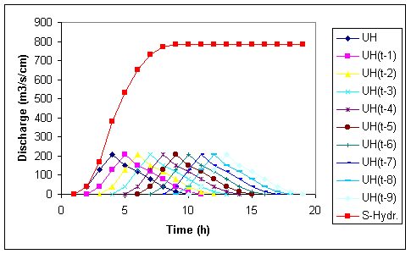

 | 1 | 2 | 3 | 4 | 5
Time (h) | 1-h UH (m³/s/cm) | S-Hyd (m³/s/cm) | Lagged  S-Hyd (m³/s/cm) | S1-S2 (m³/s/cm) | D'-UH (m³/s/cm)
1 | 0 | 0 |  | 0 | 0
2 | 40 | 40 |  | 40 | 13.33333
3 | 130 | 170 |  | 170 | 56.66667
4 | 210 | 380 | 0 | 380 | 126.6667
5 | 150 | 530 | 40 | 490 | 163.3333
6 | 120 | 650 | 170 | 480 | 160
7 | 80 | 730 | 380 | 350 | 116.6667
8 | 40 | 770 | 530 | 240 | 80
9 | 15 | 785 | 650 | 135 | 45
10 | 0 | 785 | 730 | 55 | 18.33333
11 |  | 785 | 770 | 15 | 5
12 |  | 785 | 785 | 0 | 0
13 |  | 785 | 785 | 0 | 0
14 |  | 785 | 785 | 0 | 0

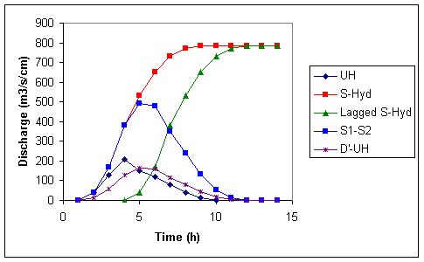

3. Determine the volume of each ERH pulse, P_{m}, expressed in units of equivalent depth:

Time  (h) | P_{m}  (cm)
0 - 3 | 3.0
3 - 6 | 6.0
6 - 9 | 4.5

4. Use superposition and proportionality principles:

 | 1 | 2 | 3 | 4 | 5 | 6
Time(h) | UH (m³/s/cm) | P₁*UH (m³/s) | P₂*UH (m³/s) | P₃*UH (m³/s) | DRH (m³/s) | Total (m³/s)
1 | 0 | 0 |  |  | 0 | 150
2 | 13.33333 | 40 |  |  | 40 | 190
3 | 56.66667 | 170 |  |  | 170 | 320
4 | 126.6667 | 380 | 0 |  | 380 | 530
5 | 163.3333 | 490 | 80 |  | 570 | 720
6 | 160 | 480 | 340 |  | 820 | 970
7 | 116.6667 | 350 | 760 | 0 | 1110 | 1260
8 | 80 | 240 | 980 | 60 | 1280 | 1430
9 | 45 | 135 | 960 | 255 | 1350 | 1500
10 | 18.33333 | 55 | 700 | 570 | 1325 | 1475
11 | 5 | 15 | 480 | 735 | 1230 | 1380
12 | 0 | 0 | 270 | 720 | 990 | 1140
13 |  |  | 110 | 525 | 635 | 785
14 |  |  | 30 | 360 | 390 | 540
15 |  |  | 0 | 202.5 | 202.5 | 352.5
16 |  |  |  | 82.5 | 82.5 | 232.5
17 |  |  |  | 22.5 | 22.5 | 172.5
18 |  |  |  | 0 | 0 | 150

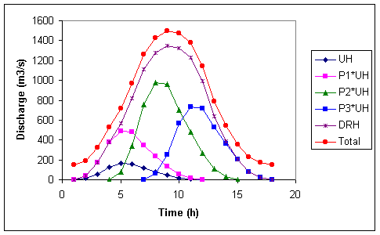
a) Columns 2 - 4: Apply the proportionality principle to scale the UH by the actual volume of the corresponding rectangular pulse, P_{m}. Observe that the resulting hydrographs are lagged so that their origins coincide with the time of occurrence of the corresponding rainfall pulse.

b) Column 5: Apply the superposition principle to obtain the DRH by summing up Columns 2 - 4.

c) Column 6: Add back the baseflow in order to obtain the Total Streamflow Hydrograph.

GIS Create Watershed
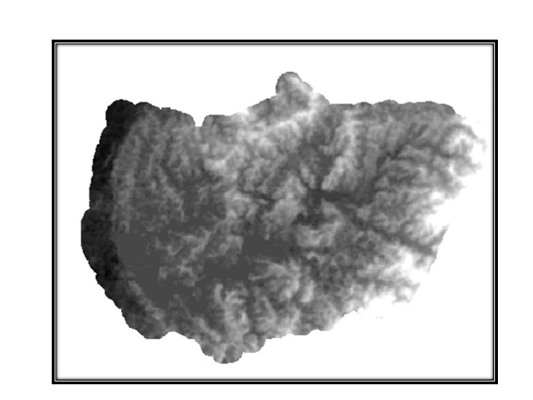
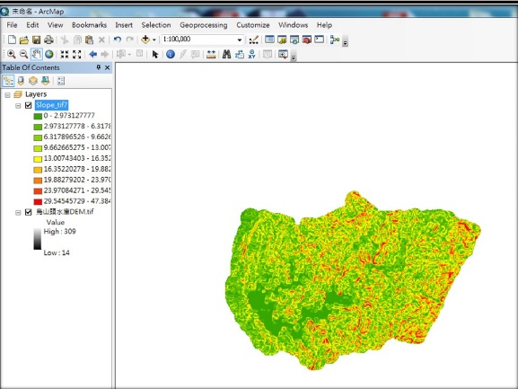
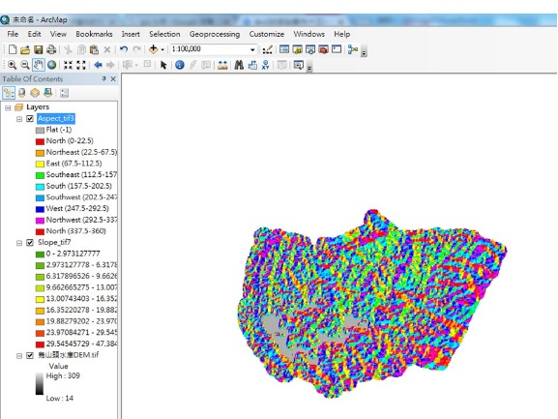
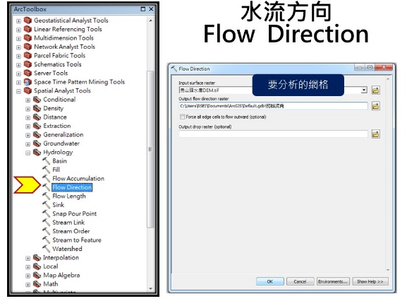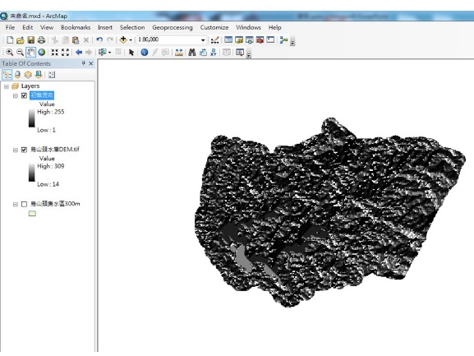
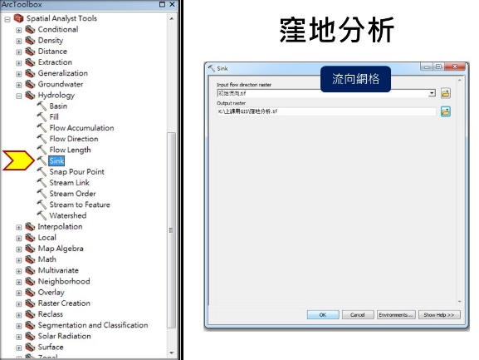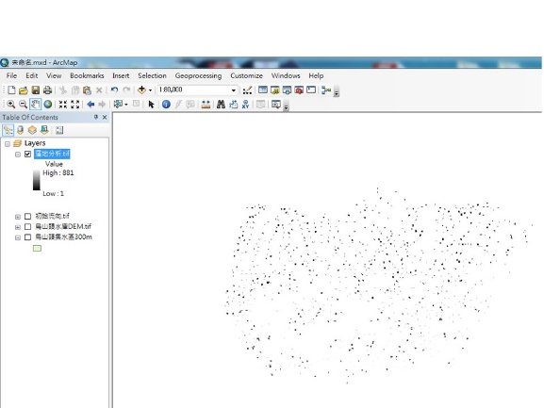
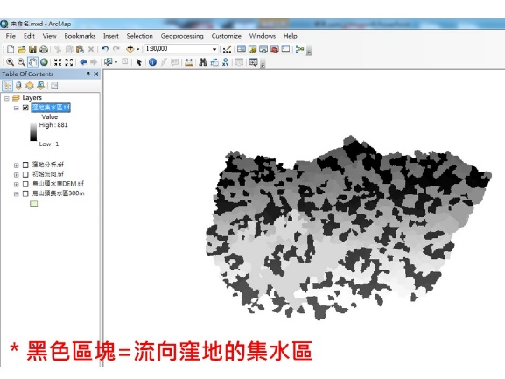
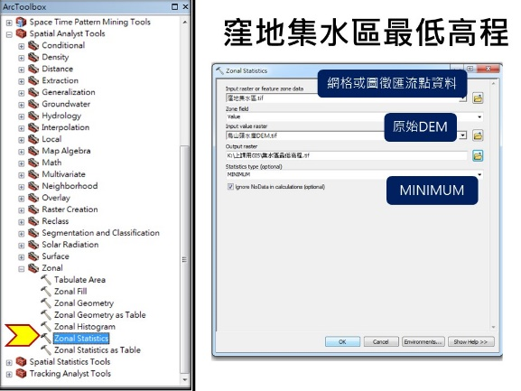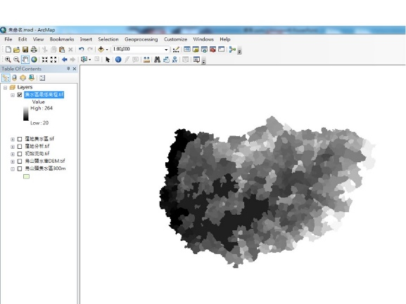
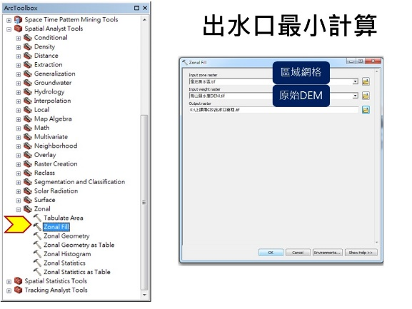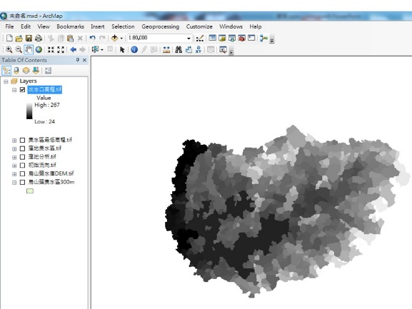

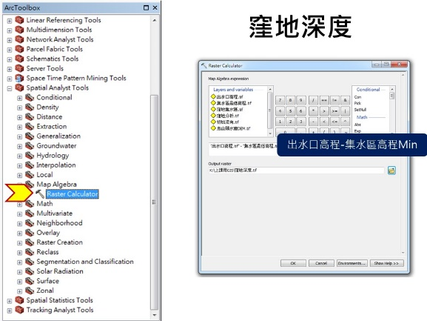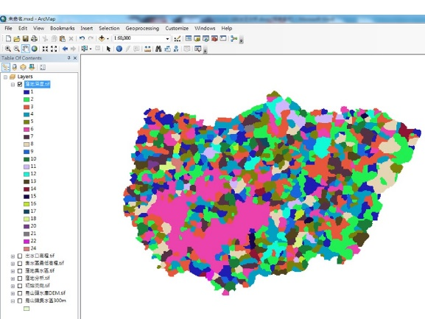
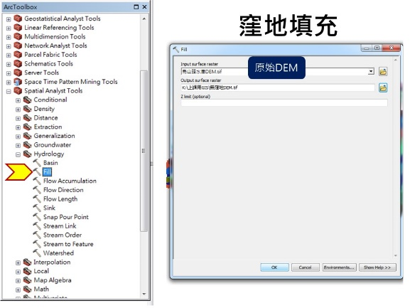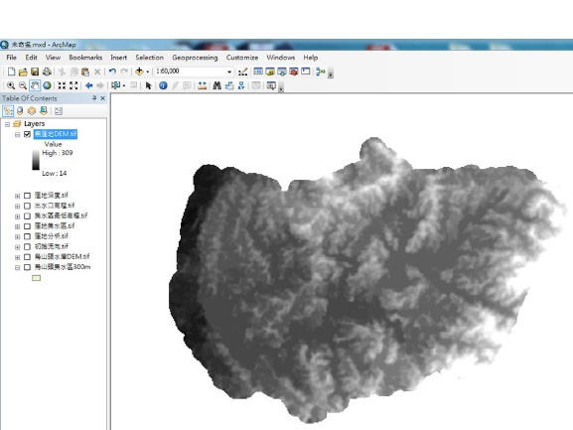
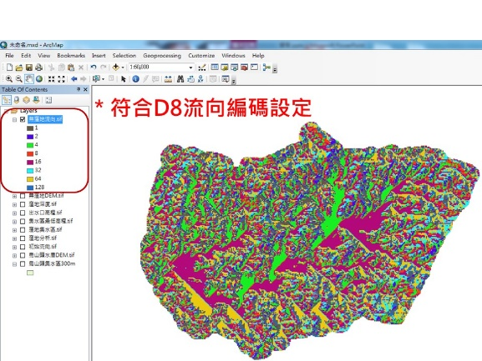


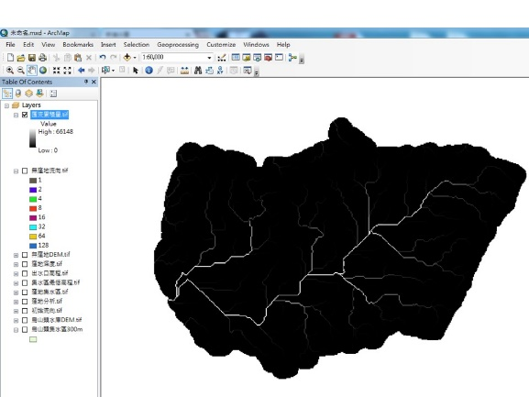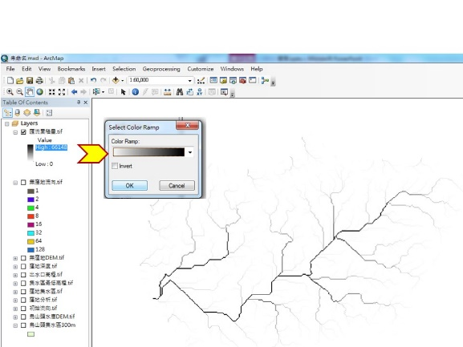
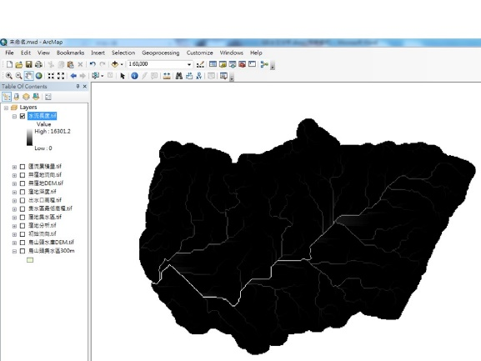

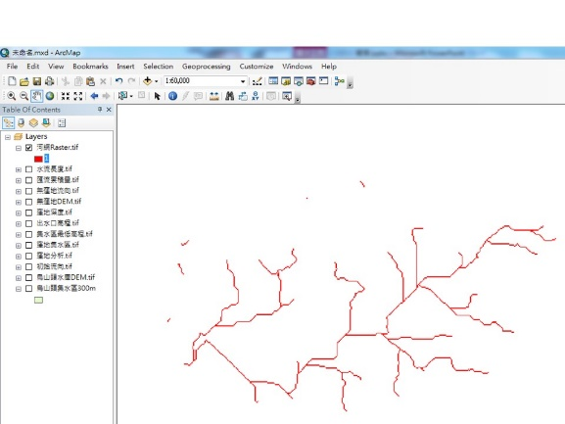

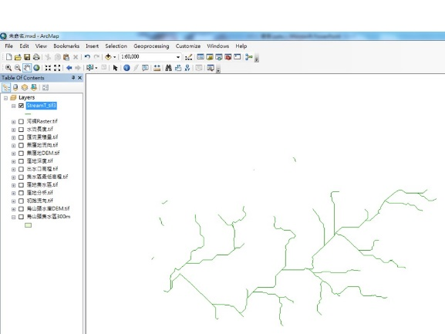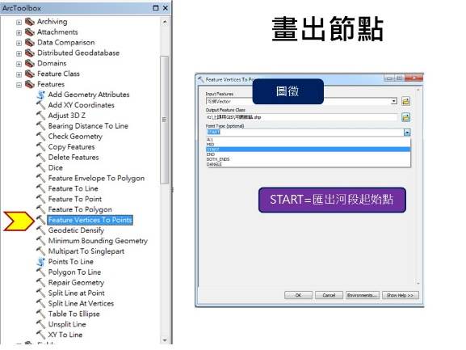
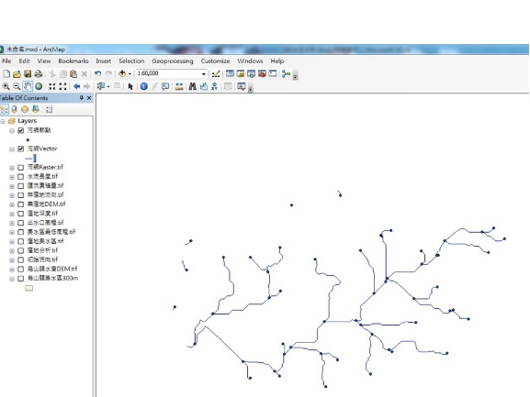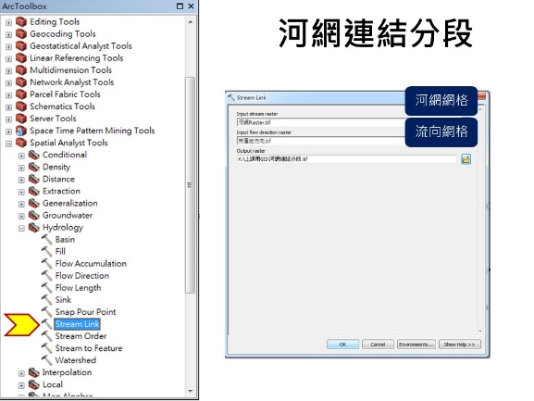
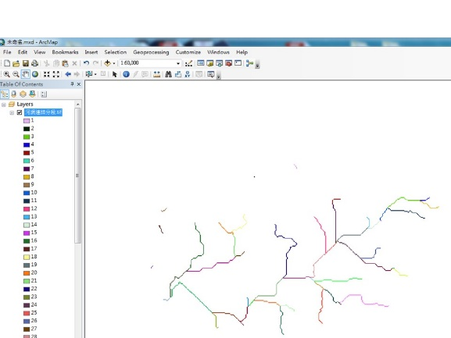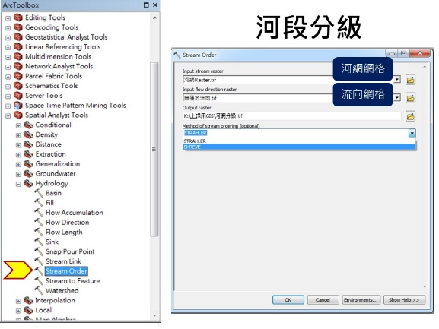
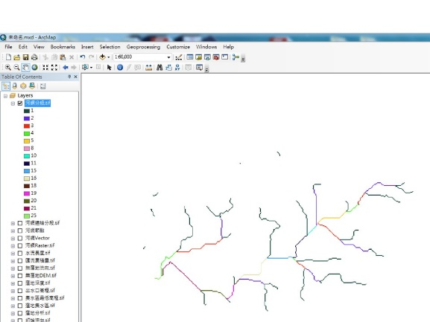

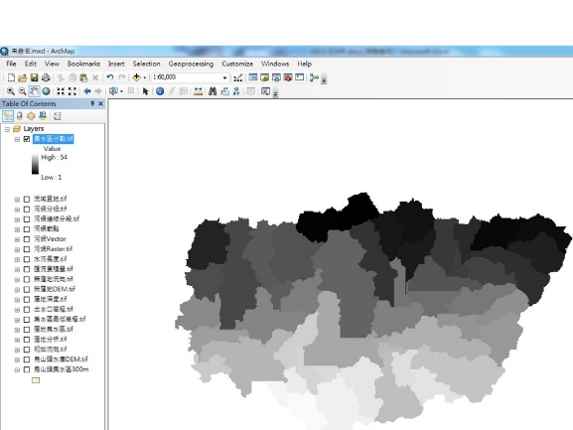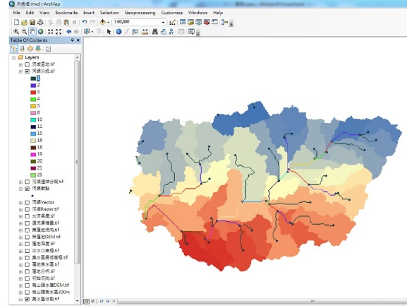

PIX4D


